**DM CASE Design**

**1 ER Diagram**

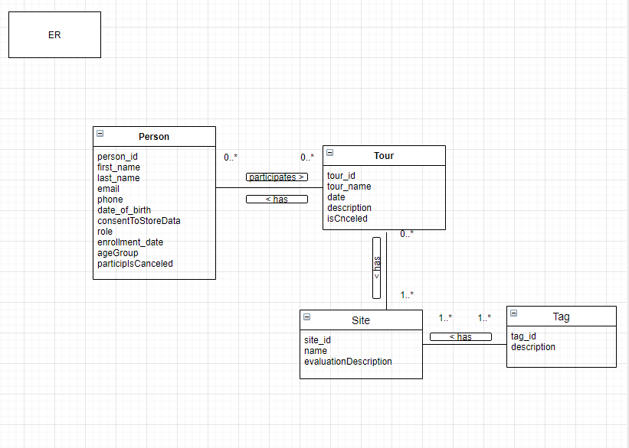

**2 Relational schema**

BCNF validation

Tour (tour_id , name, description, date, isCancelled)

PK (tour_id) -> name, description, date, isCancelled

Person (person_id , last_name, first_name, email, phone, ageGroup, consentToStoreData, enrollment_date, role)

PK (person_id) -> lats_name, first_name, email, phone, ageGroup, consentToStoreData, enrollment_date, role)

TourPerson (person_id, tour_id, particIsCanceled

PK (person_id, tour_id) -> particIsCanceled

FK person_id REFERENCES Person (person_id)

FK tour_id REFERENCES Tour (tour_id)

Site (site_id , name)

PK (site_id) -> name

TourSite (tour_id, site_id)

PK (tour_id, site_id)

FK tour_id REFERENCES Tour (tour_id)

FK site_id REFERENCES Site (site_id)

Tag ( tag_id, description)

PK (tag_id) -> description

TagSIte (tag_id, site_id)

PK (tag_id, site_id)

FK tag_id REFERENCES Tag (tag_id)

FK site_id REFERENCES Site (site_id)

SiteEvaluation (site_id, person_id, evaluation_id, description)

PK (site_id, person_id) -> evaluation_id, description

FK site_id REFERENCES Site (site_id)

FK person_id REFERENCES Person (person_id)

**3 Repository**

**ENTITY TYPE DESCRIPTIONS**

|  |  |  |  |
| --- | --- | --- | --- |
| **ENTITY TYPE** | **Description** | **Synonyms, aliases** | **Occurrence** |
| **Person** | A person who enrolls for a tour | Customer, member |  |
| **Tour** | A route that consists of combination of different sites | Trip, excursion | no less than 3 participants in each tour, otherwise - cancellation |
| **Tag** | An information related to the site | Marker, title | limitless |
| **Site** | An attraction in city what tours consists of | Waypoint | many, because each tour consists of several sites |
| **SiteEvaluation** | A record for feedback | Feedback | limitless |

**ATTRIBUTE TYPE DESCRIPTIONS**

**Person**

|  |  |  |  |  |  |
| --- | --- | --- | --- | --- | --- |
| **Attribute type** | **Description** | **Data type** | **Value**  **required** | **Identity attribute**  **or part of it** | **Special domain** |
| name | Name of a customer | Text | Yes | - | - |
| lastname | Last name of a customer | Integer | Yes | - | - |
| email | Customers e-mail address | Text | Yes | Yes | Valid e-mail format |
| phone_number | Customer phone number | Integer | Yes | - | - |
| ageGroup | Age group which customer belongs to | Text | - | - |  |
| consent | Person’s agreement on storing his data | Text | Yes | - | - |
| role | Which role the customer has while on tour | Text | Yes |  | ‘participant’, ‘organiser’ |
| enrollment_date | Date when the customer enrolled for a tour | Date |  |  |  |

**Tour**

|  |  |  |  |  |  |
| --- | --- | --- | --- | --- | --- |
| **Attribute type** | **Description** | **Data type** | **Value**  **required** | **Identity attribute**  **or part of it** | **Special domain** |
|  |  |  |  |  |  |
| name | Name of a tour | Text | Yes | Yes | - |
| description | A content of a tour | Text | Yes | - | - |
| date | Tour’s date | Date | Yes | - | - |
| isCancelled | Tour status | Text | Yes |  | ‘Y’, ‘N’ |

**SiteEvaluation**

|  |  |  |  |  |  |
| --- | --- | --- | --- | --- | --- |
| **Attribute type** | **Description** | **Data type** | **Value**  **required** | **Identity attribute**  **or part of it** | **Special domain** |
| description | Given evaluation for each site | Text | Yes | - | - |

**Site**

|  |  |  |  |  |  |
| --- | --- | --- | --- | --- | --- |
| **Attribute type** | **Description** | **Data type** | **Value**  **required** | **Identity attribute**  **or part of it** | **Special domain** |
| name | Name of a site | Text | Yes | Yes | - |

**Tag**

|  |  |  |  |  |  |
| --- | --- | --- | --- | --- | --- |
| **Attribute type** | **Description** | **Data type** | **Value**  **required** | **Identity attribute**  **or part of it** | **Special domain** |
| name | Name of a tag | Text | Yes | Yes | - |

**TABLE DESCRIPTIONS**

**Person**

|  |  |  |  |  |  |
| --- | --- | --- | --- | --- | --- |
| **Column** | **Description** | **Data type** | **Value required** | **Keys** | **Special domain** |
| Person_id | Unique person identifier | VARCHAR(5) | Yes | PRIMARY KEY  (surrogate key) | - |
| First_name | Name of person | VARCHAR(50) | Yes | - | - |
| Last_name | Surname of person | VARCHAR(50) | Yes | - | - |
| E-mail | Person’s email address | VARCHAR(50) | Yes | ALTERNATE KEY (UNIQUE) | Valid e-mail format |
| Phone_number | Person’s phone number | INTEGER | Yes | - | - |
| ageGroup | Age group a person belongs to | DATE | - |  | - |
| consentToStoreData | Person’s permission to store personal data | CHAR(1) | Yes |  | ‘N’, ‘Y’ |
| role | Which role the customer has while on tour | VARCHAR(50) | Yes |  | ‘participant’, ‘organiser’ |
| Enrollment_date | Date when person enrolled for a tour | DATETIME | Yes |  |  |

**Tour**

|  |  |  |  |  |  |
| --- | --- | --- | --- | --- | --- |
| **Column** | **Description** | **Data type** | **Value**  **required** | **Keys** | **Special domain** |
| Tour_id | Inique tour identifier | CHAR(4) | Yes | PRIMARY KEY (surrogate key |  |
| name | Name of a tour | VARCHAR(50) | Yes | - | - |
| description | A content of a tour | VARCHAR(150) | Yes | - | - |
| date | Date of the tour | DATE | Yes | - | - |
| isCancelled | Status of the tour | CHAR(1) | YES | - | ‘Y’, ‘N’ |

**TourPerson**

|  |  |  |  |  |  |
| --- | --- | --- | --- | --- | --- |
| **Column** | **Description** | **Data type** | **Value**  **required** | **Keys** | **Special domain** |
| Tour_id | Inique tour identifier | CHAR(4) | Yes | IN PRIMARY KEY FOREIGN KEY 1  => Tour |  |
| Person_id | Unique person identifier | CHAR(5) | Yes | IN PRIMARY KEY FOREIGN KEY 2  => Person |  |
| partIsCancelled | Person who cancelled his participation | CHAR(1) | Yes | - | ‘N’, ‘Y’ |

**Site**

|  |  |  |  |  |  |
| --- | --- | --- | --- | --- | --- |
| **Column** | **Description** | **Data type** | **Value**  **required** | **Keys** | **Special domain** |
| site_id | Inique site identifier | CHAR(4) | Yes | PRIMARY KEY (surrogate key) |  |
| name | Name of the site | VARCHAR(50) | Yes | ALTERNATE KEY (UNIQUE) | - |

**TourSite**

|  |  |  |  |  |  |
| --- | --- | --- | --- | --- | --- |
| **Column** | **Description** | **Data type** | **Value**  **required** | **Keys** | **Special domain** |
| Tour_id | Unique tour identifyer | CHAR(4) | Yes | IN PRIMARY KEY FOREIGN KEY 1  => Tour |  |
| site_id | Inique site identifier | CHAR(4) | Yes | IN PRIMARY KEY FOREIGN KEY 2  => Site |  |

**Tag**

|  |  |  |  |  |  |
| --- | --- | --- | --- | --- | --- |
| **Column** | **Description** | **Data type** | **Value**  **required** | **Keys** | **Special domain** |
| tag_id | Inique tag identifier | CHAR(4) | Yes | PRIMARY KEY (surrogate key) |  |
| name | Name of the tag | VARCHAR(50) | Yes | ALTERNATE KEY (UNIQUE) | - |

**SiteTag**

|  |  |  |  |  |  |
| --- | --- | --- | --- | --- | --- |
| **Column** | **Description** | **Data type** | **Value**  **required** | **Keys** | **Special domain** |
| Tag_id | Unique tag identifyer | Integer | Yes | IN PRIMARY KEY FOREIGN KEY 1  => Tag | autonumber |
| site_id | Inique site identifier | Integer | Yes | IN PRIMARY KEY FOREIGN KEY 2  => Site | autonumber |

**SiteEvaluation**

|  |  |  |  |  |  |
| --- | --- | --- | --- | --- | --- |
| **Column** | **Description** | **Data type** | **Value required** | **Keys** | **Special domain** |
| Site_id | Unique site identifier | CHAR(4) | Yes | IN PRIMARY KEY  FOREIGN KEY 1  => Site | - |
| Person_id | Unique person identifier | CHAR(5) | Yes | IN PRIMARY KEY  FOREIGN KEY 2  => Person | - |
| description | Given evaluation for each site | VARCHAR(50) | Yes | - | - |

**4 DB Diagram**

